Aloha,  
  
In June of 2009 the Public Right of Way on Hanapepe Loop on Koko Head was closed by the City and County Parks & Recreation Department because they deemed the Right of Way unsafe.  The stair way going down to the ladder that leads to the ocean was breaking apart.  The hau trees on each side of the Right of Way grew high, twisted together and were breaking through the wooden fence barrier.  The wooden ladder leading to the ocean was barely hanging on.  The Parks & Recreation Dept. gated and locked the Public Right of Way and had no set plan to fix and re-open it.  
  
The Hanapepe Public Right of Way plays an important role in accessing and exiting the ocean at Kawaihoa (Portlock Point).  This Public Right of Way is not only a great place to reach the ocean to surf, boogie board, swim or fish, but in the case of ocean emergencies in the area, this is where people can be safely brought to shore.  
  
The Livable Hawai'i Kai Hui and community members were deeply concerned about the closing of this Public Right of Way.  The Livable Hawai'i Kai Hui Cultural and Natural Resource Committee began communications with the new City and County Parks & Recreation Director Gary Cabato, and his assistant Bill Balfour, to see what we could do **together** to have the

Public Right of Way fixed and re-opened.    
  
It took some time, but we are HAPPY to share with you that through the creation of a Public / Private partnership with the Livable Hawai'i Kai Hui and the City and County Parks & Recreation Dept., the Hanapepe Public Right of Way has been fixed and re-opened.  The trees have been completely cut back, the stairway and guard rails fixed, and a new metal ladder has been installed.  
  
The Cultural and Natural Resource Committee of the Livable Hawai'i Kai Hui would like to extend our deepest mahalo to the City and County Parks & Recreation Dept. and its Director Gary Cabato and his assistant Bill Balfour for working with us.  We want to say mahalo to the homeowners who live on each side of the Public Right of Way who made a financial donation to Parks & Recreation to help pay a portion of the cost to get the trees cut back.   And most importantly we want to extend our deepest mahalo to our community members for supporting the Livable Hawaii Kai Hui initiative through your financial donations and donations of supplies. We also thank you for testifying before the Hawaii Kai Neighborhood Board about the critical importance of re-opening this Public Right of Way.

This is a true community project. Mahalo to all of you.

Now, let the summer surfing begin!  
  
Aloha,

Ann Marie Kirk  
Livable Hawai'i Kai Hui  
Cultural and Natural Resource Committee

**Hanapepe Public Right of Way**  
  
  
2009 2012  
  
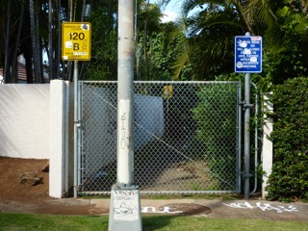       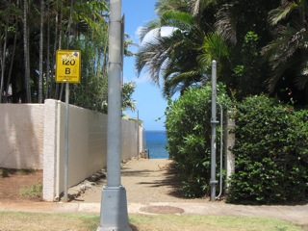  
  
2009  2012  
  
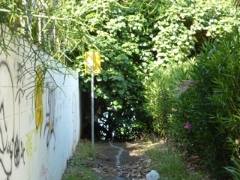       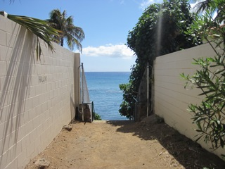

2009 2012  
  
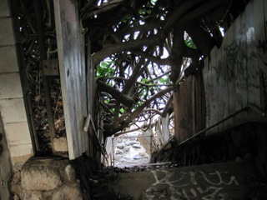        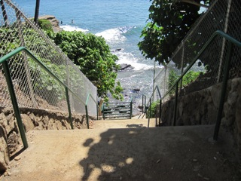  
  
2009 2012  
  
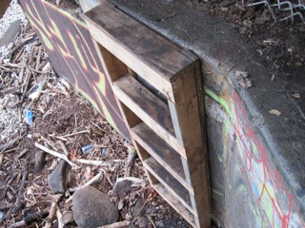       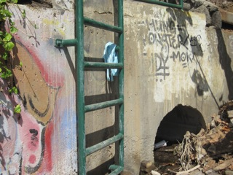  
  
  
Hanapepe Brow (Fingers) 2012  
  
